**Project Report**

# Interpolation using Lagrange and Newton Forward Formula

# Course Title:

## Numerical Computing

# Project Members:

## Taimoor Abid(11954)

## Maaz Ullah Khan Warsi(11832)

# Instructor Name:

## Sir Saad Akbar

# Introduction:

Interpolation is the process of using points with known values or sample points to estimate values at other unknown points. It can be used to predict unknown values for any geographic point data, such as elevation, rainfall, chemical concentrations, noise levels, and many more. There are many types of interpolation, but we have used two types Lagrange Interpolation And Newton Forward Method to find the missing value in between the given set of values.

## Lagrange Interpolation:

The **Lagrange interpolation** formula is a way to find a polynomial which takes on certain values at arbitrary points.

## Newton Forward Method:

Newton Forward Interpolation is the technique of estimating the value of a function for any intermediate value of the independent variable.

# Working:

We have made this project using Python Language. This project is GUI based which is done using tkinter. When we run this project it open up a window on which first it asks about which method do you want to use for finding the value, then it asks for total number of Value of X and Y and it generates an array in the backend according to our input for example if we enter 4 it will generate two arrays of 4 one for values of x and second for values of Y. Now we will enter values of X and Y in the given box. When we will enter value of X0 and enter the save button it will save the data and will ask for next value like X1 X2 so on. Then we will enter the point of which we want to find the value, or we can get the equation instead.

# Contribution in project:

We have made this project with full co-ordination we divided our work so we can do it easily and efficiently.

Taimoor Abid worked on GUI of the project and Lagrange Interpolation Method.

Maaz Ullah Warsi did most of the coding and Newton Forward Method.

# Conclusion:

We have designed this so any one can find the point or value using Lagrange or Newton Forward method easily without doing long calculations and save their time.The main difference between Lagrange and newton formula is that if difference between X is same so we use can use Newton formula and if difference between the X values is not same we can use Lagrange Interpolation Method.

# GUI Screen Shots:

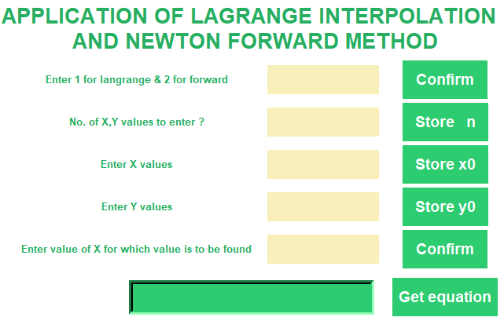

## Choosing Lagrange Method and inserting values:

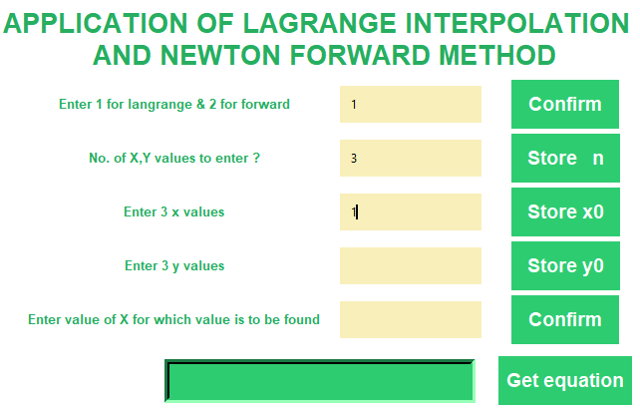

After we store the value button will change for next value and it will keep changing until we reach the total number we entered.

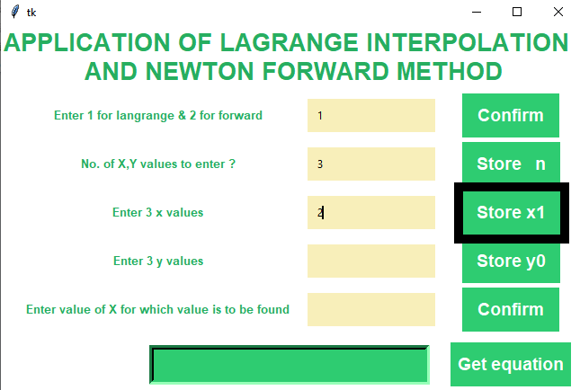

# Solving the Question Using Lagrange Method:

|  |  |  |  |  |
| --- | --- | --- | --- | --- |
| **X** | 1 | 2 | 4 | 5 |
| **Y** | 5 | 11 | 65 | 125 |

## Finding value of X at 3:

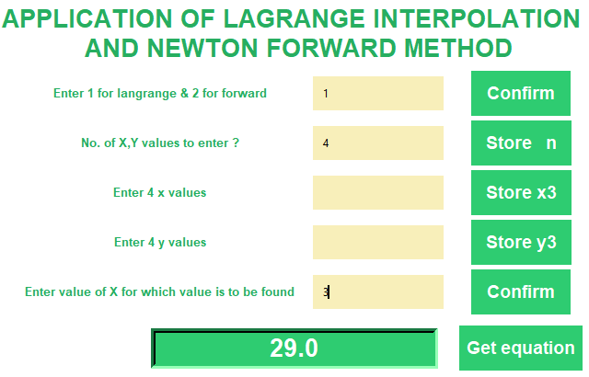

## Output with equation:

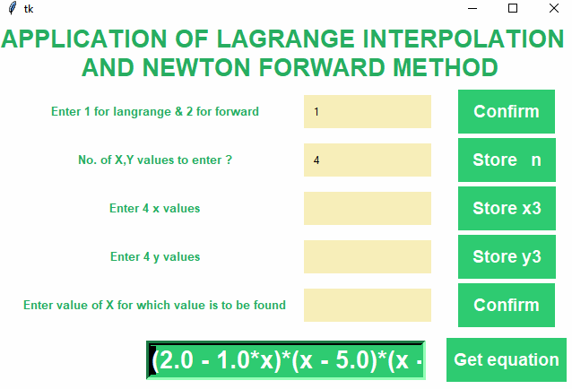

# Solving Question using Newton Forward Method:

|  |  |  |  |  |
| --- | --- | --- | --- | --- |
| **X** | 0 | 1 | 2 | 3 |
| **Y** | 3 | 12 | 81 | 200 |

## Finding value of X at 1.5:

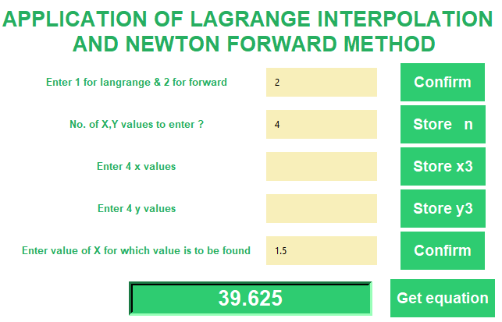

## Output with equation:

## 